Truterra Nitrogen Management Project Design Document

General Project Information

Title of Project | Truterra Nitrogen Management Project
Project Type | Regenerative Agriculture
Project Owner | Truterra, LLC
Project Developer | Truterra, LLC
Other Entities Involved in the Project | CIBO
Last Updated | 11/10/2023

1.0 GENERAL INFORMATION & DESCRIPTION 2
1.1. Description of Stand-alone Intervention or Program 2
Table 1. List of Eligible EEF Modes of Action 3
1.2. Location 4
Figure 1. Map of the United States Corn Belt 5
2.0. EMISSIONS AND/OR REMOVALS 6
2.0. Approach to Determine Activity Based Reporting 6
Figure 2. General Pathway to Quantifying the Project Emission Factor 6
Table 2. Methodology Components Used to Quantify ERs 7
2.1. Project Boundary (SSRs) 7
Table 3. VM0022 GHG Sources and Sinks 8
Table 4. CAR NMP Sources and Sinks (Applicable to both Baseline and Intervention Scenarios) 9
2.2. Description of the Baseline 11
Table 5. Summary of Intervention Activities 11
2.3. Quantification Approach 12
2.4. Accounting for Sequestration and Permanence 22
2.5. Monitoring Plan – Data and Parameters to be Monitored 22
3.0. DATA QUALITY AND MANAGEMENT 26
3.1. Quality Management Procedures and Data Quality 26
Table 6. Types of Project Data 26
4.0. IMPACT QUANTIFICATION FOR REPORTING 27
4.1. Activity Based Reporting 27
Table 7. Activity based reporting 27
4.2. Emission Factor Reporting 28
Appendix A 29

1.0 GENERAL INFORMATION & DESCRIPTION

1.1. Description of Stand-alone Intervention or Program
The Truterra Nitrogen Management Project (hereafter called “the project” or “the intervention”) is a standalone scope 3 emission reduction (ER) project developed by Truterra, LLC, an agricultural sustainability services company, and Land O'Lakes, Inc., a member-owned agricultural cooperative specializing in the production and distribution of dairy consumer packaged goods.

The project reduces the life-cycle carbon intensity through improved corn row crop fertilizer management to reduce field-level nitrous oxide (N₂O) emissions. The resulting ERs are converted to a reduced emission factor (EF), which quantifies project-based ERs per unit of crop yield, reported in tCO₂e bu⁻¹ (tonnes of carbon dioxide equivalent per bushel of corn).

Corn production requires substantial nitrogen fertilizer inputs to maintain market-competitive yields. However, significant nitrogen losses occur during each fertilizer application cycle due to volatilization, leaching or denitrification. Of particular concern is the loss of N₂O, a potent GHG with a long atmospheric lifetime. The purpose of this project is to incentivize row-crop farmers in the U.S. to participate in more efficient fertilizer-use practices, including fertilizer reductions and the use of enhanced efficiency fertilizers (EEFs) in order to reduce N₂O losses as part of the project-related scope 3 GHG accounting claims.

Description of intervention activities
The intervention reduces N₂O emissions through (i) reductions in synthetic nitrogen fertilizer use, (ii) reductions in organic nitrogen fertilizer use, (iii) the addition of enhanced efficiency fertilizers (EEFs), or (iv) any combination of the three actions taken by farmers on participating corn crop fields. Nitrogen reductions will be measured against a calculated baseline of nitrogen applied per unit of corn crop yield across available years of historic field-specific data, and then compared to the reduced nitrogen application rates in project years. The project start date is crop rotation-dependent and begins depending on the following criteria from Truterra’s implementation of the project:
- If the crop in harvest year 2023 is corn and the crop from the previous year is soybeans, then 2023 is the first project year.
- If the crop in harvest year 2023 is soybeans and the crop in harvest year 2024 is corn, then 2024 will be the first project year.
- If the field has been under a continuous corn monocropping system, then harvest year 2023 or 2024 may be the first project year.

Activities targeted by the intervention
The intervention targets business-as-usual nitrogen fertilizer application practices. This is done by (i) reducing total field-level fertilizer applications, and (ii) reducing N₂O losses through the use of EEFs. The total annual fertilizer reduction includes both organic and synthetic nitrogen-containing fertilizers. The use of EEFs includes either slow/controlled release fertilizers, which extend the release of nitrogen into the soil; nitrification inhibitors/stabilizers, which slow down the conversion of ammonium to nitrite and nitrate by soil bacteria; or urease inhibitors/stabilizers, which slow down the conversion of urea to ammonia. All three types of EEFs reduce soil nitrogen losses and may be used in the intervention (see Deviation 2 for details). EEF eligibility is determined by the product active ingredient and must be one of the four categories listed below (see Table 1). There is considerable scientific literature demonstrating that the use of EEFs and an overall reduction in applied fertilizer reduces N₂O emissions from fields under row crop farming.

Table 1. List of Eligible EEF Modes of Action
Eligible Active Ingredient | Eligible EEF Category
Nitrapyrin | Nitrification Inhibitor
Pronitridine | Nitrification Inhibitor
DCD | Nitrification Inhibitor
NBPT | Urease Inhibitor
NPPT | Urease Inhibitor
Duromide | Urease Inhibitor
Duromide + NBPT | Urease Inhibitor
NBPT + NPPT | Urease Inhibitor
DCD + NBPT | Nitrification + Urease Inhibitor
DCD + NBPT + NPPT | Nitrification + Urease Inhibitor
sulfur-coated urea | Polymer-coated
polymer-coated urea | Polymer-coated

Description of expected yield
Participating farmers provide historical yield data to Truterra for all fields enrolled in the project. This is used to determine the total volume of corn grain that is impacted by the intervention. The intervention must not adversely affect annual yields in order to maintain functional equivalence. Analyses to ensure that yields are not adversely affected by the project activities are conducted during each project year to monitor potential yield discrepancies (see section 4.3.3).

Start date of the intervention

The start date of the intervention is the 2023 crop year (as described in Section 1.1.)

Duration of the activities within the intervention and the reporting period

The reporting period for the project is a 12-month cycle following the crop harvesting schedule. For example, a crop harvest in 2023 falls within the 2023 reporting period, though the initial fertilizer application would have taken place in 2022. Any cessation of project activities or the termination of the project altogether should be decided by the project developer and participating farmers.

1.2. Location
Description of the stand-alone Intervention location and geographical boundaries
Project activities are implemented on fields located in the United States Corn Belt (see Figure 1). The project fields have been under previous commercial corn row crop production, either continuously or in a rotation, and are designated for future corn production.

Figure 1. Map of the United States Corn Belt
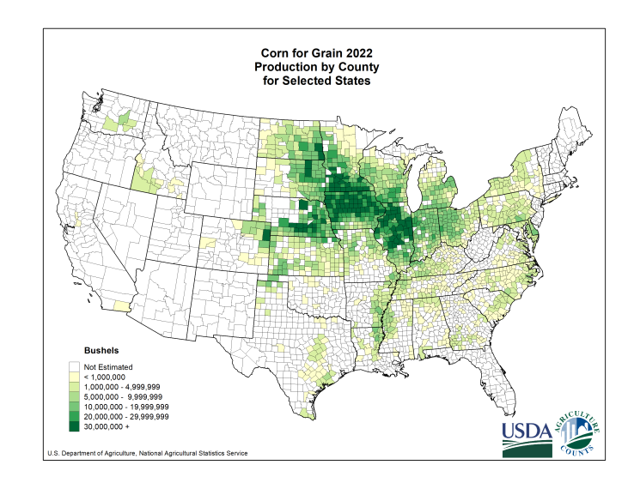
Source: https://www.nass.usda.gov/Charts_and_Maps/Crops_County/cr-pr.php

2.0. EMISSIONS AND/OR REMOVALS

2.0. Approach to Determine Activity Based Reporting
Details of the assessment of the impact on the emissions changes from the activity linked to goods and services targeted

Truterra intends to assess the impact of project ERs resulting from the implementation of the activities listed in Section 1.1. This is done by quantifying the total decrease in N₂O emissions relative to a predetermined baseline composed of historical fertilizer application data for each field. The difference in N₂O emissions between the baseline and the project scenarios makes up the project ERs. This value is then used to determine the reduced EF for corn produced in the project and all other goods containing project-grown corn (see Figure 2). ERs are first quantified on a field-by-field basis and then aggregated for the entire project, as detailed in Sections 2.2 and 2.3.

Figure 2. General Pathway to Quantifying the Project Emission Factor

Difference in Baseline and Project Emissions
Baseline N₂O Emissions
Project EF
(tCO₂e bu⁻¹)
Project ERs
(tCO₂e)

Project N₂O Emissions

The intervention determines ERs across fields with varying baseline and project fertilizer application practices. To accurately quantify ERs, two forms of variation are taken into account:
- The variation between baseline and project fertilizer application practices on the same field, and
- The variation in total fertilizer application practices between fields.
In order to accurately calculate all emission reductions, a flexible quantification approach was developed using a combination of two publicly available carbon credit methodologies: Verra’s VM0022 - Quantifying N₂O Emissions Reductions in Agricultural Crops through Nitrogen Fertilizer Rate Reduction v1.1 (“VM0022”) and the Climate Action Reserve’s Nitrogen Management Protocol v2.1 (“CAR NMP”). Table 2 outlines how each methodology is used to quantify project ERs and identifies methodology deviations where applicable.

Table 2. Methodology Components Used to Quantify ERs
Activity | Proposed Methodology | Methodology Components | Deviations
Synthetic nitrogen rate reduction | Verra VM0022 Protocol, Quantifying N2O Emissions Reductions in Agricultural Crops through Nitrogen Fertilizer Rate Reduction v1.1 | Section 8: Quantification of baseline emissions and project emissions. | Deviation 1
Organic nitrogen rate reduction | Verra VM0022 Protocol, Quantifying N2O Emissions Reductions in Agricultural Crops through Nitrogen Fertilizer Rate Reduction v1.1 | Section 8: Quantification of baseline emissions and project emissions. | Deviation 1
Use of enhanced efficiency fertilizers (EEFs) | Climate Action Reserve Nitrogen Management Protocol, version 2.1 | CAR NMQuanTool v2.0  The quantification tool is used to perform a linear extrapolation to determine the nitrogen-reducing effect of EEFs in isolation (without fertilizer reductions). | Deviation 2
Fertilizer conversion factors | Climate Action Reserve Nitrogen Management Protocol, version 2.1 | Protocol Appendix E: Default Values for Average Fertilizer N Concentration and Fertilizer Weights. | N/A

2.1. Project Boundary (SSRs)
Identification of all sources and sinks (and related GHGs) relevant to the baseline
Project ERs are determined using a combination of VM0022 and CAR NMP. To incorporate proper GHG accounting, total sources, sinks and reservoirs (SSRs) from both methodologies are used (Table 2 and Table 3). SSRs that are under the 5% materiality threshold or can be justified as remaining the same or less in the project scenario as compared to baseline emissions (considering the principles of completeness, relevance and transparency) are excluded.

Table 3. VM0022 GHG Sources and Sinks
Source |  | GHG | Included? | Justification / Explanation
Baseline | Direct emissions synthetic fertilizer | CO₂ | No | Not significant - under 5% materiality
Baseline | Direct emissions synthetic fertilizer | CH₄ | No | Not significant - under 5% materiality
Baseline | Direct emissions synthetic fertilizer | N₂O | Yes | N₂O is the major emissions source from N fertilizer
Baseline | Indirect emissions synthetic fertilizer | CO₂ | No | Not significant - under 5% materiality
Baseline | Indirect emissions synthetic fertilizer | CH₄ | No | Not significant - under 5% materiality
Baseline | Indirect emissions synthetic fertilizer | N₂O | Yes | N₂O is the major emissions source from N fertilizer
Baseline | Direct emissions organic fertilizer | CO₂ | No | Not significant - under 5% materiality
Baseline | Direct emissions organic fertilizer | CH₄ | No | Not significant - under 5% materiality
Baseline | Direct emissions organic fertilizer | N₂O | Yes | N₂O is the major emissions source from N fertilizer
Baseline | Indirect emissions organic fertilizer | CO₂ | No | Not significant - under 5% materiality
Baseline | Indirect emissions organic fertilizer | CH₄ | No | Not significant - under 5% materiality
Baseline | Indirect emissions organic fertilizer | N₂O | Yes | N₂O is the major emissions source from N fertilizer
Intervention | Direct emissions synthetic fertilizer | CO₂ | No | Not significant - under 5% materiality
Intervention | Direct emissions synthetic fertilizer | CH₄ | No | Not significant - under 5% materiality
Intervention | Direct emissions synthetic fertilizer | N₂O | Yes | N₂O is the major emissions source from N fertilizer
Intervention | Indirect emissions synthetic fertilizer | CO₂ | No | Not significant - under 5% materiality
Intervention | Indirect emissions synthetic fertilizer | CH₄ | No | Not significant - under 5% materiality
Intervention | Indirect emissions synthetic fertilizer | N₂O | Yes | N₂O is the major emissions source from N fertilizer
Intervention | Direct emissions organic fertilizer | CO₂ | No | Not significant - under 5% materiality
Intervention | Direct emissions organic fertilizer | CH₄ | No | Not significant - under 5% materiality
Intervention | Direct emissions organic fertilizer | N₂O | Yes | N₂O is the major emissions source from N fertilizer
Intervention | Indirect emissions organic fertilizer | CO₂ | No | Not significant - under 5% materiality
Intervention | Indirect emissions organic fertilizer | CH₄ | No | Not significant - under 5% materiality
Intervention | Indirect emissions organic fertilizer | N₂O | Yes | N₂O is the major emissions source from N fertilizer
Sink |  | Included in Quantification Approach? |  | Explanation
Above-ground woody biomass |  | No |  | Not relevant and not subject to quantifiable change
Above-ground non-woody biomass |  | No |  | Not relevant and not subject to quantifiable change
Below-ground biomass |  | No |  | Not relevant and not subject to quantifiable change
Litter |  | No |  | Not relevant and not subject to quantifiable change
Dead Wood |  | No |  | Not relevant and not subject to quantifiable change
Soil |  | Yes |  | Change is nil or positive; to be quantified
Wood products |  | No |  | Not relevant and not subject to quantifiable change

Table 4. CAR NMP Sources and Sinks (Applicable to both Baseline and Intervention Scenarios)
Source |  | GHG | Included? | Justification / Explanation
Primary Effect Sources, Sinks and Reservoirs
Soil Dynamics | Soil interactions produce emissions | CO₂ | No | Soil carbon is expected to increase slightly or remain stable, therefore excluding is conservative
Soil Dynamics | Soil interactions produce emissions | CH₄ | No | Methane production and oxidation is insignificant for non-flooded soils
Soil Dynamics | Soil interactions produce emissions | N₂O | Yes | The primary effect of a nitrogen management plan is a reduction in N₂O emissions from soil
LRVO | Leaching volatilization and runoff (LRVO) of applied nitrogen, followed by denitrification into N₂O | CO₂ | No | N/A
LRVO |  | CH₄ | No | N/A
LRVO |  | N₂O | Yes | A primary effect of nitrogen management projects, this may be a significant portion of overall N₂O emission reductions
Secondary Effect Sources, Sinks, and Reservoirs
Cultivation Equipment | Fossil fuel emissions from project equipment | CO₂ | No | Not significant – under 5% materiality
Cultivation Equipment | Fossil fuel emissions from project equipment | CH₄ | No | Not significant - under 5% materiality
Cultivation Equipment | Fossil fuel emissions from project equipment | N₂O | No | Not significant - under 5% materiality
Irrigation | Irrigation impacts soil N₂O emissions, and changes in irrigation may increase associated fossil fuel usage | CO₂ | No | Not significant – under 5% materiality
Irrigation |  | CH₄ | No | Not significant - under 5% materiality
Irrigation |  | N₂O | No | Not significant – under 5% materiality
Offsite Storage of Manure | Indirect emissions from changes in storage of manure source | CO₂ | No | Supply of manure is relatively inelastic, and end-of-life fate is likely to remain land application, therefore this source is excluded
Offsite Storage of Manure | Indirect emissions from changes in storage of manure source | CH₄ | No
Offsite Storage of Manure | Indirect emissions from changes in storage of manure source | N₂O | No
Fertilizer Transportation | Changes in fertilizers used may change associated transport emissions | CO₂ | No | Not significant - under 5% materiality
Fertilizer Transportation |  | CH₄ | No | Not significant - under 5% materiality
Fertilizer Transportation |  | N₂O | No | Not significant - under 5% materiality
Shifted Production (Leakage) | Decreased project yields may result in increased cultivation outside the project area | CO₂ | No | Not significant - under 5% materiality
Shifted Production (Leakage) |  | CH₄ | No | Not significant - under 5% materiality
Shifted Production (Leakage) |  | N₂O | Yes | Any significant decreases in yield must be accounted for, as production is assumed to shift outside of project area
Synthetic Fertilizer Production | Decreases in synthetic fertilizer use may affect a decrease in fertilizer production | CO₂ | No | It is conservative to exclude this category as emissions from this SSR will decrease
Synthetic Fertilizer Production |  | CH₄ | No
Synthetic Fertilizer Production |  | N₂O | No
Production & Use of Chemical Inputs | Changes in nutrient management practices may impact how much lime or herbicides are used on fields | CO₂ | No | Excluded, as approved project activities are unlikely to materially increase the use of lime or herbicide on fields
Production & Use of Chemical Inputs |  | CH₄ | No
Production & Use of Chemical Inputs |  | N₂O | No

2.2. Description of the Baseline
Baseline status of the proposed intervention

Table 5. Summary of Intervention Activities
Intervention | Activity | Geography  (Supply Shed) | Yield Impacted | Baseline Emissions
Nitrogen management | Use of an enhanced efficiency fertilizer (EEF) | Corn Supply Shed | Measured annually after crop harvest | See section 2.3
Nitrogen management | Synthetic/organic N rate reduction | Corn Supply Shed | Measured annually after crop harvest | See section 2.3

The baseline, defined according to VM0022, constitutes the continuation of historical cropping and fertilizer management practices where, in the absence of the improved fertilizer management practices in the project scenario, fertilizer application rates would continue in a business-as-usual manner. This would result in higher N₂O emissions compared to the project scenario. The baseline emissions thus quantify the amount of N₂O that would have been emitted during the project period if the project had not been implemented.

VM0022 provides two approaches to determining the baseline scenario. Approach 1 quantifies the baseline nitrogen fertilizer rate based on farm management records for the previous three crop years of corn, regardless of rotation history. All relevant baseline farm management records have been obtained by Truterra via direct communication with participating farms and are transferred into a standardized format for baseline reporting and project-related record-keeping (see section 3.1).

If farm management records cannot be obtained, or if the required number of baseline years is unavailable, then Approach 2 is used. In Approach 2, the baseline nitrogen fertilizer rate is calculated from crop yield data at the county level (available from the United States Department of Agriculture – National Agricultural Statistics Service (USDA – NASS)) and equations for determining nitrogen fertilizer rate recommendations based on yield goal estimates (found in e.g., state department of agriculture and university agricultural extension documents). In order to use Approach 2, farmers are required to provide the years in which the project crop (corn) has been harvested on the project site prior to the intervention year. The requirements to use Approach 2 are outlined in detail in VM0022.

Total amount of goods affected

Corn grain is the only commercial good that will be affected by the project. Annual yields may not decrease due to project activities and must be maintained. Yield decreases must be evaluated on a per-field basis as the number of participating farms may change in each project year depending on crop rotations (see Section 3.1 for details).

2.3. Quantification Approach
Description of the approach to quantifying emissions in both baseline and intervention scenarios

All ERs are quantified using the top-down approach provided in VM0022 with the exception of EEF-based reductions, which are quantified using data and guidelines provided in the CAR NMP (see Table 2 and Deviation 2).

The methodologies were selected based on the project’s ability to meet all applicability conditions laid out in VM0022 Section 4 and CAR NMP Section 2.2. All required evidence to demonstrate methodology applicability is provided throughout the document.

Methodology Deviations

Deviation 1. Field-level Calculations

The VM0022 methodology is not written to include multiple farms within the scope of a single project. For clarification purposes, all equations have been adjusted to denote calculations at the field-level denoted by the index “f” in the equation subscript. All calculations in sections 2.3 (Baseline Quantification and Project Quantification) are done on a per-field basis. The impact of the whole intervention is determined as an aggregate of all field-level for each project year.

Deviation 2. Integrating EEF Emission Reductions

Several baseline and project fertilizer applications include the use of enhanced efficiency fertilizers (EEFs) – synthetic fertilizers that have been formulated to reduce nutrient losses. Three types of EEFs are commonly used, with two different ER effects: 1. slow-release fertilizers and urease inhibitors, and 2. nitrification inhibitors. The nitrogen loss-reducing effect of EEFs varies depending on field-level environmental conditions such as geographical location, irrigation, and tillage practices. For this reason, a standardized value for EEF-induced emission reductions must be modeled. The CAR NMP includes a quantification tool (NMQuanTool) that uses Daycent modeling to determine EEF-based ERs. The NMQuanTool is appropriate to quantify EEF reductions for this intervention because it is part of an approved and publicly available nitrogen fertilizer-reduction protocol.

The CAR NMP is designed to encourage total reductions in synthetic fertilizer and does not allow protocol users to generate ER credits solely from the application of EEFs. In the NMQuanTool, the total possible fertilizer reductions range from 5-30%. The tool then calculates ERs based on the following additional inputs: state county, crop type, field acres, irrigation, EEF use (nitrification inhibitors or slow-release fertilizers), and conversion to short-term no till. Outputs from the NMQuanTool indicate a nearly linear relationship when plotting combined ERs from nitrogen reductions and EEF use as well as ERs from nitrogen reductions only (see Excel Attachments: EEF Extrapolation & NMQuanTool). The effect of EEFs on the NMQuanTool’s ER estimates is linearly extrapolated to determine the ER effect resulting from a 0% fertilizer reduction. The calculations are done to estimate EEF-based ERs for one acre. All project counties yield the same results in the NMQuantTool, so calculations are not adjusted on a per-county basis. Irrigation and conversion to short term no till were not included in the calculations.

Extrapolation was performed for both nitrification inhibitors and slow release fertilizers/urease inhibitors resulting in the following:

Nitrification Inhibitors: ${EEF}_{effect}=0.115 {tCO}_{2}e {ac}^{-1}=0.285{ MgCO}_{2}e {ha}^{-1}$
Slow-Release Fertilizers & Urease Inhibitors: ${EEF}_{effect}=0.068 {tCO}_{2}e {ac}^{-1}=0.167 {MgCO}_{2}e {ha}^{-1}$

Dual Mode of Action Inhibitors (Nitrification + Urease Inhibitors): ${EEF}_{effect}=0.183 {tCO}_{2}e {ac}^{-1}=0.452 {MgCO}_{2}e {ha}^{-1}$

EEFs are distinguished by type (slow-release, urease inhibitor, nitrification inhibitor) in the baseline and the project scenario. A set of eligibility rules determine the effect of EEF applications. These rules generate the number of eligible project EEF applications, which are multiplied by the EEF reduction effect (EEF_{effect}) to quantify the total EEF-based reduction. The eligibility rules are as follows:
- If the number of EEF applications in the project scenario ≤ the number of baseline EEF applications (i.e., there are no eligible EEF applications), then no project EEF deductions may be taken.
- If the number of EEF applications in the project scenario > the number of EEF applications in the baseline, then the difference between the (project scenario applications – baseline applications) are credited by EEF type.

The above rules encourage farmers to apply EEFs in the project scenario without penalizing farmers that do not. For example, if a farmer applied an EEF in the baseline but not in the project, the effect of baseline EEF application is not subtracted from the baseline. Instead, the EEF effect for baseline applications is set to zero.

Baseline Emissions

The following section outlines the procedure to determine baseline emissions for farms participating in the intervention. Total baseline emissions are calculated using the following equation:

$N_{2}O_{B total, f, t}=N_{2}O_{B direct, f, t}+{{ N}_{2}O}_{B indirect, f, t}$
Where:
N₂O_{B total, f, t} | Total baseline N₂O emissions applied to intervention field f in year t (Mg CO₂e ha⁻¹)
N₂O_{B direct, f, t} | Direct baseline N₂O emissions from intervention field f in year t (Mg CO₂e ha⁻¹)
N₂O_{B indirect, f, t} | Indirect baseline N₂O emissions beyond the intervention field f in year t (Mg CO₂e ha⁻¹)

Direct Baseline Emissions

The direct baseline N₂O emissions from nitrogen fertilizer applications using VM0022 Method 1 are calculated using the following equations:

Substituted data using Approach 2 is included as a synthetic fertilizer (F_{B SN, f, t}) per guidelines in VM0022.

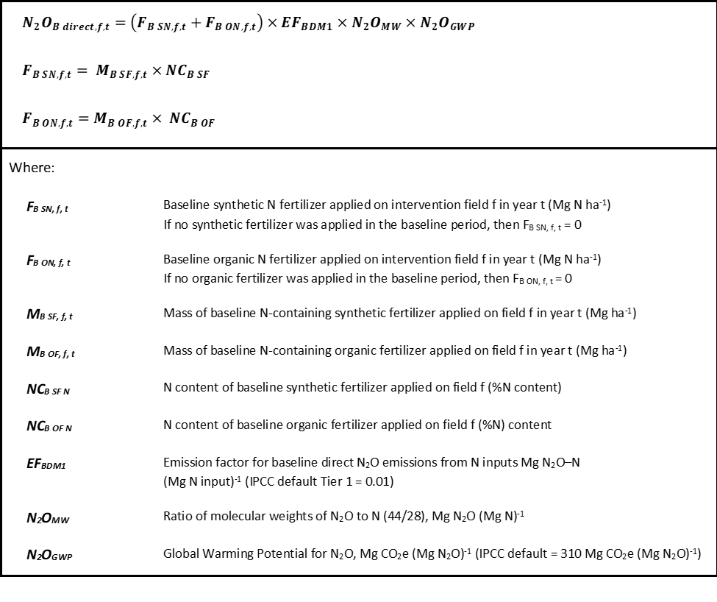

Indirect Baseline Emissions

The indirect baseline N₂O emissions from nitrogen fertilizer applications are calculated using the following equations:
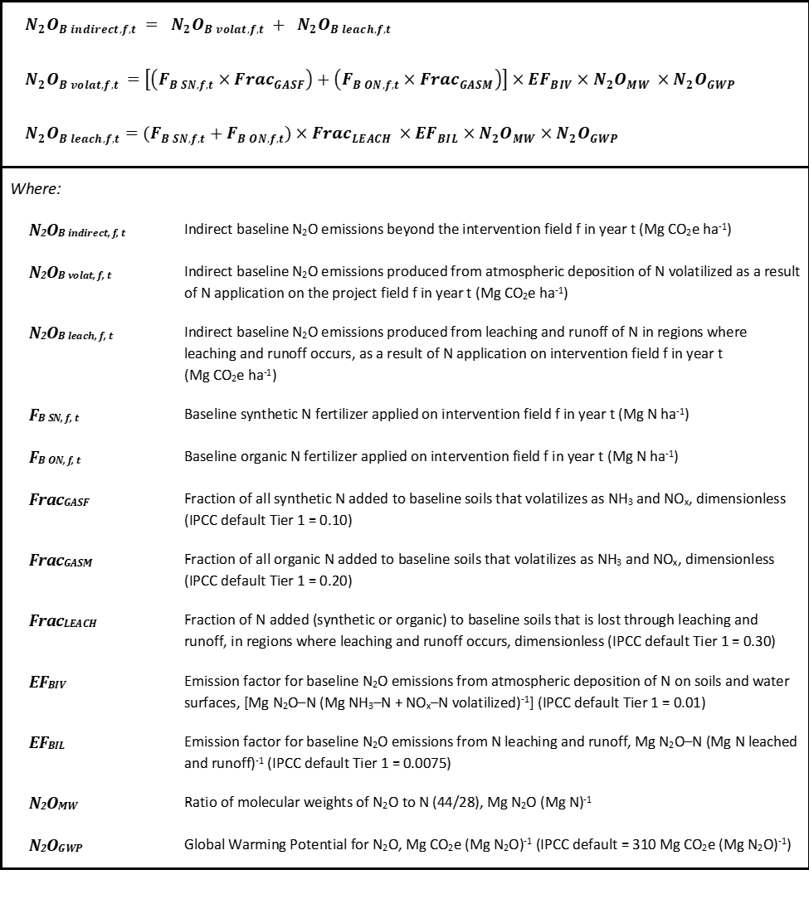

Project Emissions

The following section outlines the procedure to determine project emissions for farms participating in the intervention. Total project emissions are calculated by the following equation:

$${N_{2}O}_{P total, f, t}={N_{2}O}_{P direct, f, t }+{N_{2}O}_{P indirect, f, t}-{EEF}_{P, f, t}$$
Where:
N₂O_{P total, f, t} | Total project N₂O emissions for intervention field f in year t (Mg CO₂e ha⁻¹)
N₂O_{P direct, f, t} | Direct project N₂O emissions from intervention field f in year t (Mg CO₂e ha⁻¹)
N₂O_{P indirect, f, t} | Indirect project N₂O emissions from intervention field f in year t (Mg CO₂e ha⁻¹)
EEF_{P, f, t} | Total N-reducing effect of EEFs applied on intervention field f in year t (Mg CO₂e ha⁻¹)

Direct Project Emissions
Direct project N₂O emissions from nitrogen fertilizer applications are calculated using the following equations: 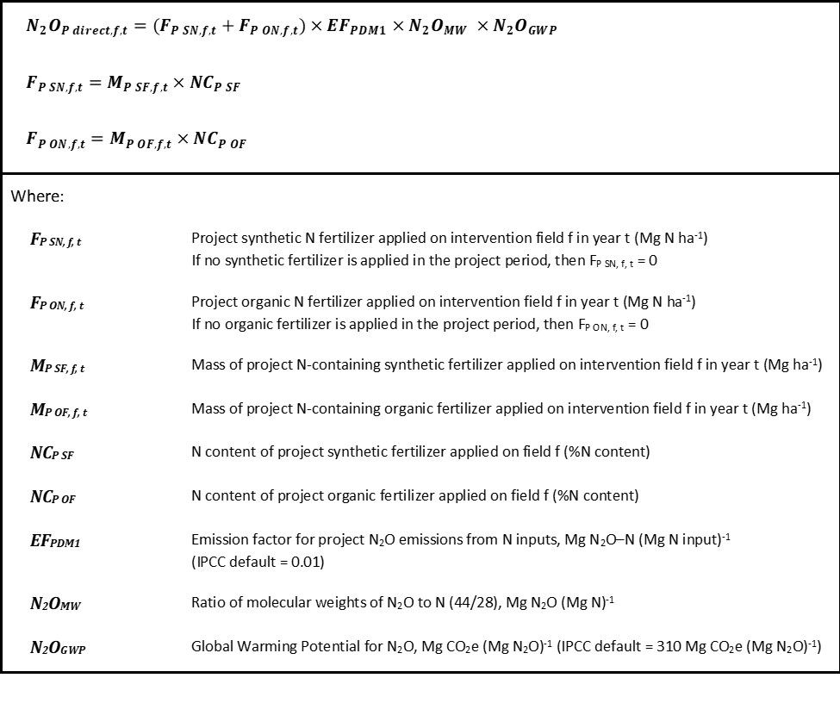

Indirect Project Emissions

Indirect project emissions are calculated using the following equations:
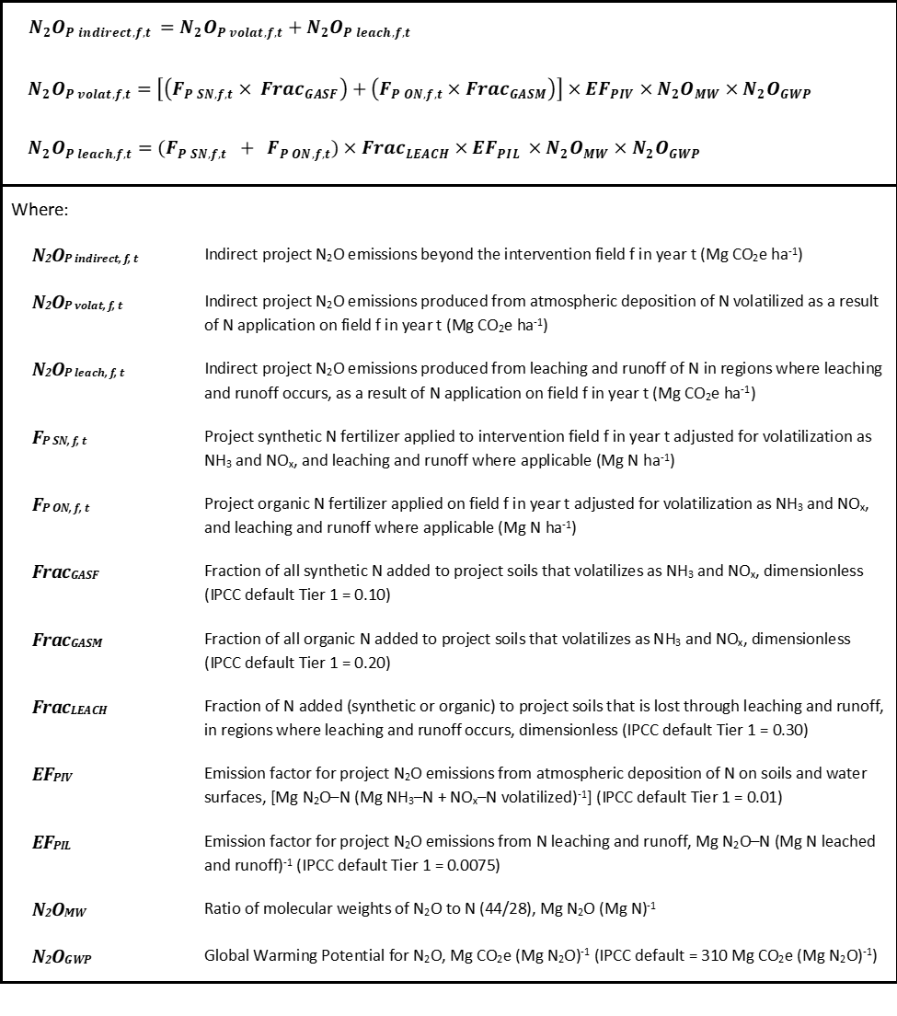

Effect of Enhanced Efficiency Fertilizers in the Intervention

The effect of EEFs in the intervention are calculated using the following equations and Deviation 2:

$${ EEF}_{reduction}=Σ{EEF}_{total}×{EEF}_{effect}$$
$${ EEF}_{total}={EEF}_{P, app, f, t}-{EEF}_{B, app, f, t }$$
Where:
EEF_{reduction} | N reduction resulting from the application of EEFs in the project scenario.
EEF_{effect} | N-reducing effect of EEFs (Mg CO₂e ha⁻¹) This may be either a nitrification inhibitor or a slow release fertilizer. See Deviation 2 for details.
EEF_{total} | Number of total eligible EEFs in the project scenario
EEF_{P, app, f, t} | Number of project EEF applications on field f in year t
EEF_{B, app, f, t} | Number of baseline EEF applications on field f in year t

Leakage

According to VM0022, there are no leakage deductions for this intervention type because the land in the project scenario remains maintained for commodity production.

Total Emission Reductions

The following equation calculates the N₂O emission reductions brought about by the intervention implementation. Total project emission reductions are first determined by subtracting the sum of project emissions on each field for each project year from the sum of baseline emissions on each field for each baseline year, multiplied by the total area of the intervention. This value is then further reduced by intervention uncertainty to determine final emission reductions.

Total ERs are calculated on a per-field basis using the equation below. The intervention total is the sum of N₂O_{PR} for all fields.

Where:
N₂O_{PR} | Reduction in total N₂O emissions brought about by project implementation  (Mg CO₂e)
N₂O_{B total, f, t} | Total baseline N₂O emissions applied to intervention field f in year t  (Mg CO₂e ha⁻¹)
N₂O_{P total, f, t} | Total project N₂O emissions for intervention field f in year t (Mg CO₂e ha⁻¹)
AP | Project area (ha)

Data Availability Unit Conversions

All baseline and project fertilizer data has been obtained by Truterra through direct communications with participating farmers. For each fertilizer application, farmers were asked to indicate the product used (e.g., UAN-32 synthetic fertilizer or dairy manure), the state in which it was applied (liquid or solid), the total amount applied per acre, and a breakdown of the N-P-K (nitrogen, phosphorus and potassium) content by weight. Where not provided directly by the farmer, the N-P-K breakdown was determined by an internal reference document (see Appendix A, “Cheat Sheet Fertilizer Compiled.docx”), using the more conservative estimate if a range was given, nitrogen content provided by the product manufacturer, or organic fertilizer values cited in “Manure Characteristics, MWPS-18 Section 1. Second Edition. Ames, IA: Midwest Plan Service.”

Description activities resulting in GHG emissions reductions beyond what would occur in comparison to the determined GHG baseline

The intervention activities represent new activities on enrolled farms that have not been implemented during the baseline period. In the absence of the intervention, farmers have little incentive to reduce their nitrogen fertilizer applications due to the risk of reduced yields.

Description conservative quantification approach

The intervention calculations are done in accordance with known and approved GHG accounting methodologies (VM0022 and CAR NMP), which have been written to be conservative. In the event that data must be substituted due to the inability to collect 5-6 years of baseline data, then conservative county level data will be used as a replacement, as approved in VM0022 Approach 2.

The inclusion of EEF nitrogen reductions always uses the more conservative value in the estimation of baseline and project reductions when exact data on the type of EEF used is unavailable. All requirements for maintaining conservative EEF deductions are outlined in the Methodology Deviation 2.

Additionally, the EF is scaled according to yield size to account for any leakage that may have occurred from lower crop yields resulting from any project activities.

Justification of the relevance, completeness, consistency and accuracy of the quantification approach for the activities included in the intervention

All GHG accounting is done using the quantification procedures outlined in approved top-down carbon offset methodologies and the corresponding deviations listed in this document, ensuring accuracy and completeness of quantification.

References, limitations, and assumptions applied

Baseline and project activities relevant to the intervention are accounted for through data collected from farms participating in the project. All data reported to the project is directly from farm management records to ensure traceability and accuracy. The data obtained by Truterra falls within the reporting requirements for the GHG boundaries laid out in VM0022 and the CAR NMP. This includes crop type, planting and harvesting dates, total yields, fertilizer application dates, and fertilizers used in each application. Additionally, the size and location of each project field is recorded. Any missing data is substituted in accordance with permissible data substitution guidelines outlined in the implemented GHG accounting methodologies.

Description of the assessment of risks potentially affecting expected emissions reductions and related mitigation measures introduced

The following risks are identified as the most likely to affect the expected project ERs. Measures to mitigate the potential impact of each risk are addressed.
- Project-related yield decreases: Reduced nitrogen fertilizer applications may decrease yields to a point where it adversely affects harvest income. A decrease in yield may be exacerbated by unexpected events such as drought conditions.
- Farmers leaving the intervention: Farmers may choose to exit the program and no longer participate in intervention activities. All legitimate ERs from farms that have decided to discontinue the program will be reported for the time that they were participating. Following their departure, all baseline and project data will be removed from program quantification and reporting documents.
- Increase in nitrogen fertilizer applications: Farmers may increase their nitrogen fertilizer applications relative to the baseline. This would appear in the project ER calculations and would reduce the total available ERs for that reporting year. Increases in fertilizer applications will be addressed on a case-by-case basis to evaluate reasons for the increase and to plan for a continuation in reductions during the following year.

Total amount of goods affected

Corn produced on all participating fields is the only commodity that is affected by the intervention.

2.4. Accounting for Sequestration and Permanence
There is no need to address permanence because the project ERs come from the avoidance of N₂O emissions.

2.5. Monitoring Plan – Data and Parameters to be Monitored
Description of the Monitoring Plan for both intervention and baseline

The intervention requires several parameters to be monitored for baseline determination and for each project year after (outlined below). Monitored parameters are in accordance with those required by VM0022 with the addition of an EEF parameter and yield data for annual EF determination. All parameters require annual monitoring unless otherwise stated, in line with corporate accounting principles.

Monitored data must be obtained by Truterra directly from farmers and requires primary source reporting directly from their original farm management records.

List of data/parameters that will be monitored

Baseline Data Parameters Required at Project Initiation

Data / Parameter: | Project Crop Area
Unit | Hectares (ha); may also be reported in acres (ac) and converted to ha.
Description | Area of crop(s) planted, from which project fertilizer N rate is determined.
Source of data | Farm management records reported by participating farms.
Value(s) applied | Varies by field.
Measurement methods and procedures, including QA/QC | As per requirements of VCS version 3 “Project location for AFOLU projects must be specified using geodetic polygons to delineate the geographic area of each AFOLU project activity and provided in a KML file”.
Monitoring frequency | Every five years and at each addition of new fields to the grouped project.
Roles & responsibilities | Truterra
Controls | Sub-Process: TT CR – Quality Assurance of Truterra Carbon Program Data.
Data management | Truterra’s internal record keeping (TST).

Data / Parameter: | MB_{SF, f, t}
Unit | Mg N field⁻¹ yr⁻¹
Description | Mass of synthetic N-containing fertilizer applied in the baseline.
Source of data | Farm management records reported by participating farms.
Value(s) applied | Varies by field and year.
Measurement methods and procedures, including QA/QC | Generally accepted field application methods using calibrated applicators of known capacity for fertilizer mass or volume determination. Weight and volume unit conversions follow the guidelines in Appendix A where applicable. Data for this parameter must include the name of the product used, the physical state in which the product was applied (liquid or solid) and the N-P-K values (if applicable).
Monitoring frequency | Must be collected for each baseline year that was a corn crop in accordance with the guidelines set forth in VM0022 Approach 1. If VM0022 Approach 2 is used, this parameter shall only report the years in which a corn crop was grown in the baseline in accordance with the requirements to use VM0022 Approach 2 (see section 4.2).
Roles & responsibilities | Truterra
Controls | Sub-Process: TT CR – Quality Assurance of Truterra Carbon Program Data.
Data management | Truterra’s internal record keeping (TST).

Data / Parameter: | MB_{OF, f, t}
Unit | Mg N field⁻¹ yr⁻¹
Description | Mass of organic N-containing fertilizer applied in the baseline.
Source of data | Farm management records reported by participating farms.
Value(s) applied | Varies by field and year.
Measurement methods and procedures, including QA/QC | Generally accepted methods using calibrated applicators of known weight/volume for liquid and solid organic material application. Weight and volume unit conversions follow the guidelines in CAR NMP Appendix E where applicable. Data for this parameter must include the name of the product used, the physical state in which the product was applied (liquid or solid) and the N-P-K values (if applicable).
Monitoring frequency | Must be collected for each baseline year that was a corn crop in accordance with the guidelines set forth in VM0022 Approach 1. If VM0022 Approach 2 is used, this parameter shall only report the years in which a corn crop was grown in the baseline in accordance with the requirements to use VM0022 Approach 2 (see Section 4.2).
Roles & responsibilities | Truterra
Controls | Sub-Process: TT CR – Quality Assurance of Truterra Carbon Program Data.
Data management | Truterra’s internal record keeping (TST).

Data / Parameter: | NC_{B SF}
Unit | g N (100g fertilizer)⁻¹
Description | Nitrogen content of synthetic fertilizer applied in the project, including the fertilizer type applied.
Source of data | Farm management records reported by participating farms.
Value(s) applied | Varies by product type.
Measurement methods and procedures, including QA/QC | Generally accepted procedures for sampling, handling and analysis of bulk fertilizer. In the event that this information is not provided by the farmer, a substitute value may be obtained per the guidelines in CAR NMP Appendix E or product manufacturer specifications.
Monitoring frequency | Must be collected for each baseline year that was a corn crop in accordance with the guidelines set forth in VM0022 Approach 1. If VM0022 Approach 2 is used, this parameter shall only report the years in which a corn crop was grown in the baseline in accordance with the requirements to use VM0022 Approach 2 (see section 4.2).
Roles & responsibilities | Truterra
Controls | Sub-Process: TT CR – Quality Assurance of Truterra Carbon Program Data.
Data management | Truterra’s internal record keeping (TST).

Data / Parameter: | NC_{B OF}
Unit | g N (100g fertilizer)⁻¹
Description | Nitrogen content of organic fertilizer applied in the project, including the fertilizer type applied.
Source of data | Farm management records reported by participating farms.
Value(s) applied | Varies by product type.
Measurement methods and procedures, including QA/QC | Generally accepted sampling and handling procedures for organic materials. Laboratory analysis for total N using total Kjeldahl Nitrogen [TKN] or total N by combustion). In the event that this information is not provided by the farmer, a substitute value may be obtained per the guidelines in CAR NMP Appendix E.
Monitoring frequency | Must be collected for each baseline year that was a corn crop in accordance with the guidelines set forth in VM0022 Approach 1. If VM0022 Approach 2 is used, this parameter shall only report the years in which a corn crop was grown in the baseline in accordance with the requirements to use VM0022 Approach 2 (see Section 4.2).
Roles & responsibilities | Truterra
Controls | Sub-Process: TT CR – Quality Assurance of Truterra Carbon Program Data.
Data management | Truterra’s internal record keeping (TST).

Data / Parameter: | EEF_{B, app, f, t}
Unit | N/A
Description | Number of EEF applications per field in each project year.
Source of data | Farm management records reported by participating farms.
Value(s) applied | Varies by field and year.
Measurement methods and procedures, including QA/QC | Reported by product type (e.g., nitrification inhibitor or slow release fertilizer) if possible. Reporting required for each crop year based on farm management records.
Monitoring frequency | Must be collected for each baseline year in which a corn crop was grown.
Roles & responsibilities | Truterra
Controls | Sub-Process: TT CR – Quality Assurance of Truterra Carbon Program Data.
Data management | Truterra’s internal record keeping (TST).

Description of the sampling approach

All data parameters are monitored for each field enrolled in the project in accordance with the data monitoring requirements set forth in VM0022 and the deviations. This includes the monitoring of farmer records that document project-relevant farming data . Farm records are consolidated by Truterra via their web-based data collection system.

Sampling of monitored parameters is done annually pre- and post-harvest. All participating farmers have attested to Truterra that they are accurately reporting all of their data. A copy of physical farm records may be requested by Truterra if additional monitoring is deemed necessary.

For the purposes of the monitoring plan, a field is defined as a contiguous geographic area for which all data parameters are reported within the scope of the requirements in section 4.5.4. The sampling of monitored parameters is carried out at all project fields. If a farmer decides to discontinue the program, monitoring and reporting will no longer take place on the field(s) taken out of the project.

3.0. DATA QUALITY AND MANAGEMENT

3.1. Quality Management Procedures and Data Quality
Truterra collects data on several different parameters from participating farms in order to determine baseline and project scenario emissions. The data types used in all baseline and project quantifications fall into two broad categories: primary data and secondary data (see Table 5). Primary data is collected directly from the farm management records of participating farmers. The data parameters required for baseline and project scenario reporting outlined in section 2.5 are all considered primary data and must be collected from participating farmers by Truterra. Secondary data is either obtained from the two methodologies (VM0022 and CAR NMP) or from reputable third-party sources proposed in deviations outlined in section 2.3.

Table 6. Types of Project Data
Type of Data | Definition | Data Example
Primary Data | Data on specific field-level management activities that is obtained directly from farm management records for each participating field. | - Project field areas.  - Baseline and project fertilizer application rates.  - Type of fertilizer used.  - Project crop yields.  - Number of baseline and project EEF applications.
Secondary Data | Data that is not specific to any field management activity and complements missing field-level data. | - Estimated baseline fertilizer applications using VM0022 Approach 2.  - EEF emissions reduction estimates (Deviation 2).

Truterra collects all relevant project information through a group of data coordinators and field data specialists, who coordinate data collection with farm operators and steward data from initial collection to storage in the TST. Their primary responsibilities include:
- Review farm operator contact information for accuracy
- Confirm initial enrollment data with farm operator
- Review field boundaries and confirm with farm operator
- Work with farm operator to fill out data collection template
- Review data for accuracy and gaps
- Take corrective action to remove inaccuracies and fill gaps in data
- Transfer data into the TST for permanent storage

Data managers receive twelve hours of initial training on the project design and the data manager roles and responsibilities, including how to use the data collection template and ensure accuracy and completeness of data. They receive three hours of continuing education each week.
All of the primary, site-specific data is collected from farm operator management logs, invoices, receipts, farm equipment specifications, farm management software downloads and/or reports and nutrient management plans. The data is prepared using a data collection template and imported into the TST for permanent storage.

Data quality is ensured by the QA/QC procedures that Truterra uses for data collection:
- A set of preset options for all data parameters (see section 2.5) are in place to reduce the risk of inaccurate data entry.
- Data validation value ranges are applied in TST for select data parameters (see section 2.5) to ensure feasibility of values.
- In the event that further discrepancies appear in the data, Truterra may follow up with participating farmers individually to obtain all necessary data.

The data collected by Truterra is recorded and maintained in the TST by data coordinators and field data specialists. This includes all farm operator information, field ownership information, and field eligibility data. The TST database in which the data is stored is only managed by Truterra. The project data is backed up according to Truterra’s internal enterprise information technology (IT) policy.

4.0. IMPACT QUANTIFICATION FOR REPORTING

4.1. Activity Based Reporting

All activities implemented to reduce N₂O emissions in the intervention fall within the scope 3 boundary and can be used to make scope 3 related ER claims. There are no further project activities that are making ER claims that fall within or outside of the scope 3 boundary. The full list of ER activities that fall within the project scope are outlined in Table 7.

Table 7. Activity based reporting
Activity | Inside Scope 3 Boundary? | Reduced tCO₂e
Synthetic nitrogen rate reduction | Yes | Measured using quantification approach in section 4.3.
Organic nitrogen rate reduction | Yes | Measured using quantification approach in section 4.3.
Use of an enhanced efficiency fertilizer (EEF) | Yes | Measured using quantification approach in section 4.3.

4.2. Emission Factor Reporting
Details on intentions to assess the impact on the EF

An emission factor (EF) is calculated for the corn crop of each project year. The EF is calculated both on a per-field basis and for the entire intervention (all fields aggregated). The equation below, which is adopted from section 1.15 of “Gold Standard Value Chain (Scope 3) Interventions – Greenhouse Gas Accounting and Reporting Guidance v1.1,” indicates how the EF must be determined in conjunction with the ER calculations from section 2.3.

Total corn yield is measured and reported in bushels. Since the EF is part of the scope 3 reporting for this project, annual corn yield is included as a project parameter in section 3.5 and must be measured and reported annually.

The EF is calculated using the following equation:

$${ EF}_{t}={{N_{2}O}_{PR, t} }/{ Y_{corn, t}}$$
Where:
EF_{t} | Project emission factor for project year t (Mg CO₂e/bu corn)
N₂O_{PR} | Reduction in total N₂O emissions brought about by project implementation in year t (Mg CO₂e)
Y_{corn, t} | Total corn yield for project year t (bu)

Appendix A
Image of internal reference document “Cheat Sheet Fertilizer Compiled.docx”:
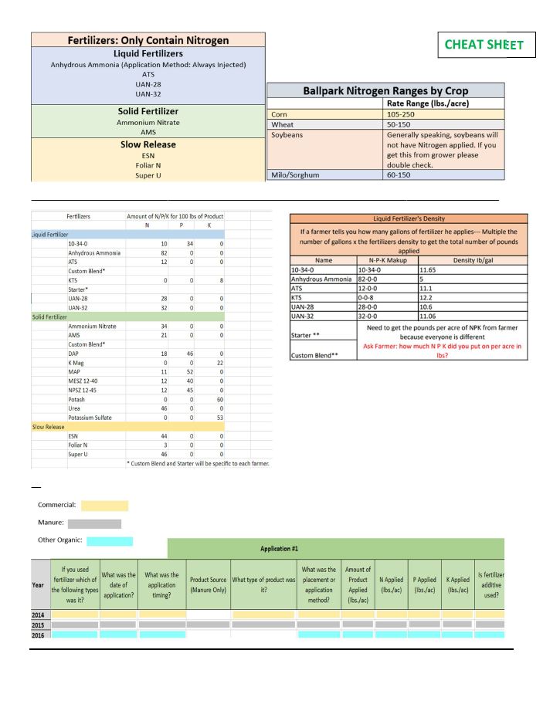
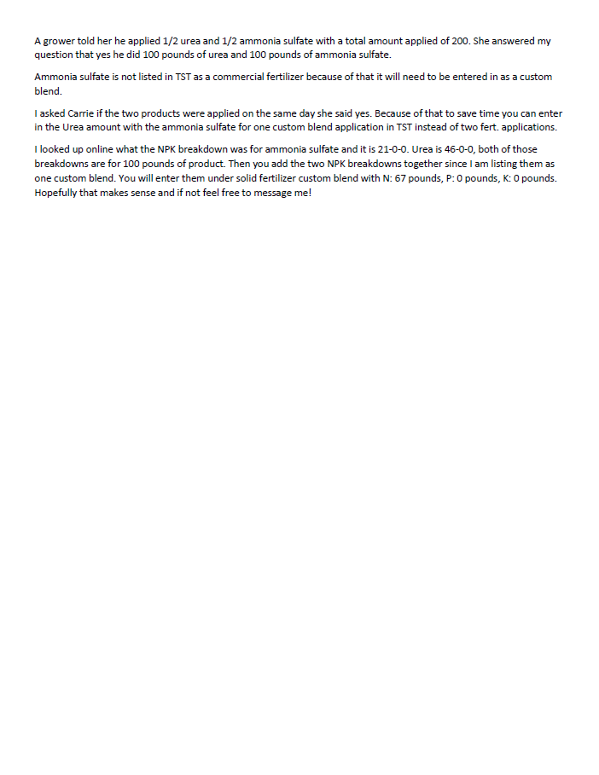

https://www.epa.gov/ghgemissions/overview-greenhouse-gases
Fernández, F.G., Venterea, R.T. and Fabrizzi, K.P. (2016), Corn Nitrogen Management Influences Nitrous Oxide Emissions in Drained and Undrained Soils. J. Environ. Qual., 45: 1847-1855. https://doi.org/10.2134/jeq2016.06.0237
Parkin, Timothy B. and Hatfield, Jerry L., "Enhanced Efficiency Fertilizers: Effect on Nitrous Oxide Emissions in Iowa" (2013). Publications from USDA-ARS / UNL Faculty. 1353; Peter A. Ingraham, William A. Salas, Assessing nitrous oxide and nitrate leaching mitigation potential in US corn crop systems using the DNDC model, Agricultural Systems, 10.1016/j.agsy.2019.05.005, 175, (79-87), (2019)
https://verra.org/methodologies/vm0022-quantifying-n2o-emissions-reductions-in-agricultural-crops-through-nitrogen-fertilizer-rate-reduction-v1-1/
https://www.climateactionreserve.org/how/protocols/ncs/nitrogen-management/
Truterra has developed an internal process to provide data quality assurance and maintain data quality controls throughout each project year. Detailed information on all data QA/QCs can be found in the attached document “Sub-Process: TT CR – Quality Assurance of Truterra Carbon Program Data.”

